**Problem 2: Contour Modeling**

* 1. **Summary**

We will implement two algorithms: the snake algorithm and the level-set algorithm in this problem. Both algorithm is used to detect contour in the gray image. These algorithms are widely used in the field of Biomedical Imaging to detect the contour.

* 1. **Algorithm and Implementation**

The snake algorithm (Active Contour Model) is an energy-minimizing spline. This algorithm is influenced by lines and edges of the image and also influence by external selection of contour initialization [1]. The code of Snake algorithm is provided by Ritwik Kumar, Snakes: Active Contour Models [4].

The Level-set algorithm is introduced by Osher and Sethian in 1987 which is used to capture the contour of the image. The basic idea of level set is that first choose a Level Set Function (LSF) as a zero-level set of a higher dimensional function, then evolution the level-set function to detect the contour [2]. The code of Level-set algorithm used here is provided by Chunming Li, Level set for image segmentation [3].

* 1. **Result**

**2.3.1 Extract the contour of the spine**

The contour results of Spine image are Figure, 2, 3. Figure 1, 2 are Snake algorithm, Figure 3 is Level-Set algorithm.

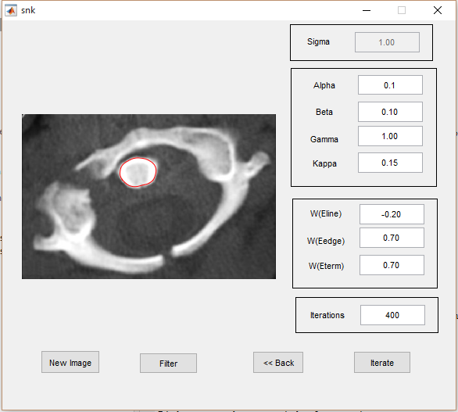

**Figure 1. Snake Algorithm of Spine. Alpha = 0.1, Beta = 0.1, Wline = -0.2, Wedge = 0.7, Wterm = 0.7**

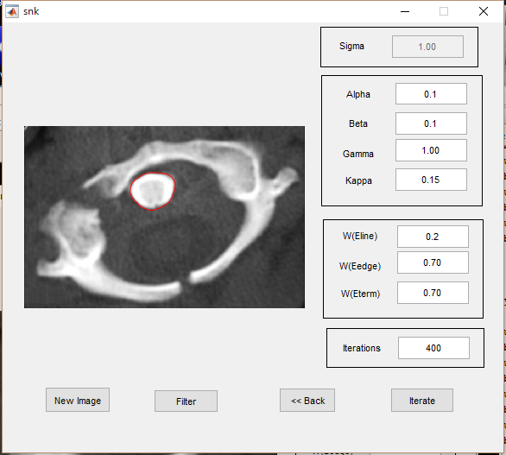

**Figure 2. Snake Algorithm of Spine. Alpha = 0.1, Beta = 0.1, Wline = 0.2, Wedge = 0.7, Wterm = 0.7**

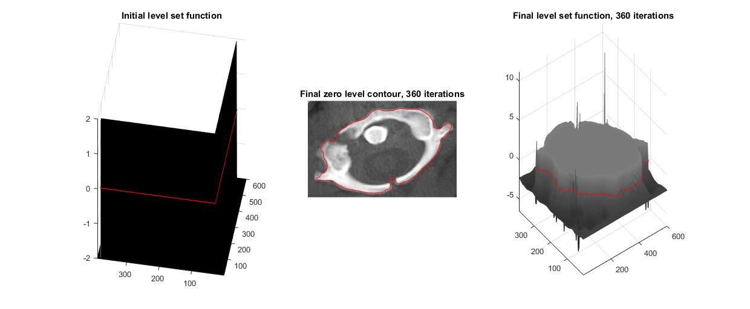

**Figure 3. Level-Set Algorithm of Spine. Lambda = 5, Alpha = 2**

**2.3.2 Extract the outline of coronary from the following angiogram image**

The contour results of Coronary image are Figure, 2, 3. Figure 1, 2 are Snake algorithm, Figure 3 is Level-Set algorithm.

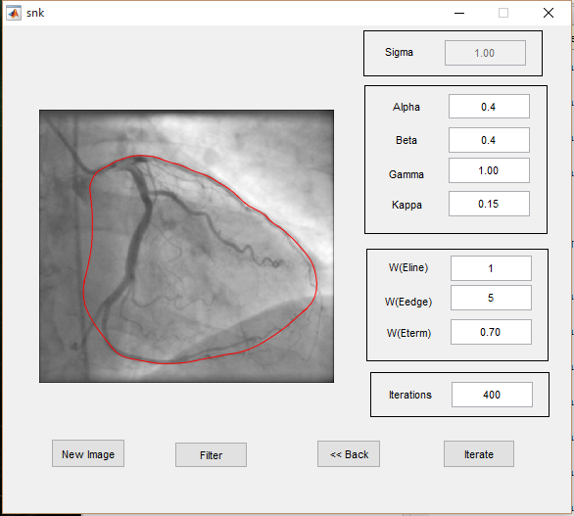

**Figure 2. Snake Algorithm of Coronary. Alpha = 0.4, Beta = 0.4, Wline = 1, Wedge = 5, Wterm = 0.7**

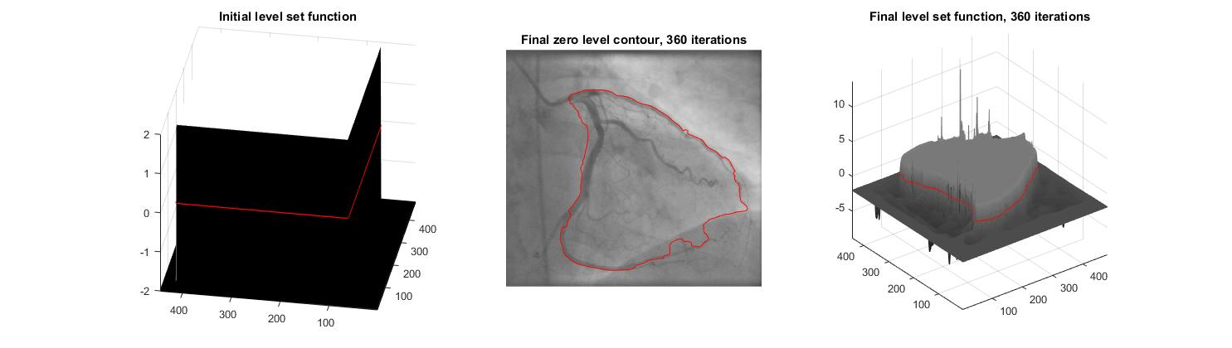

**Figure 3. Level-Set Algorithm of Coronary. Lambda = 5, Alpha = 2**

**2.3.3 Separate red and white blood cells**

The contour results of Blood Cell image are Figure, 2, 3. Figure 1, 2 are Snake algorithm, Figure 3 is Level-Set algorithm.

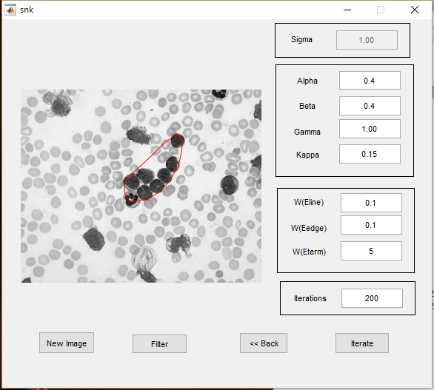

**Figure 2. Snake Algorithm of Blood Cell Alpha = 0.4, Beta = 0.4, Wline = 0.1, Wedge = 0.1, Wterm = 5**

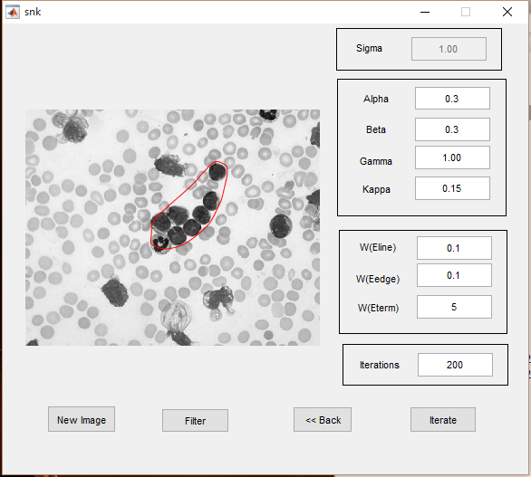

**Figure 2. Snake Algorithm of Blood Cell Alpha = 0.3, Beta = 0.3, Wline = 0.1, Wedge = 0.1, Wterm = 5**

**Figure 3. Level-Set Algorithm of Blood Cells. Lambda = 5, Alpha = 2**

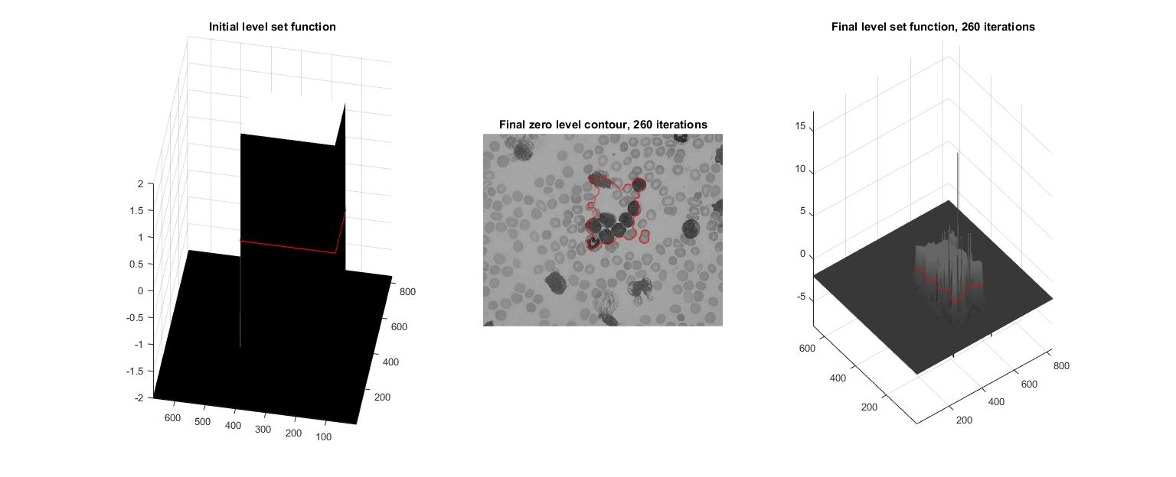

**2.3.4 Isolate the tumor in the brain MIR image**

The contour results of Brain image are Figure, 2, 3. Figure 1, 2 are Snake algorithm, Figure 3 is Level-Set algorithm.

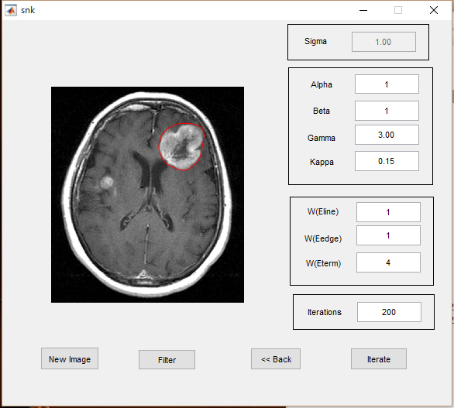

**Figure 2. Snake Algorithm of Brain Image. Alpha = 1, Beta = 1, Wline = 1, Wedge = 1, Wterm = 4**

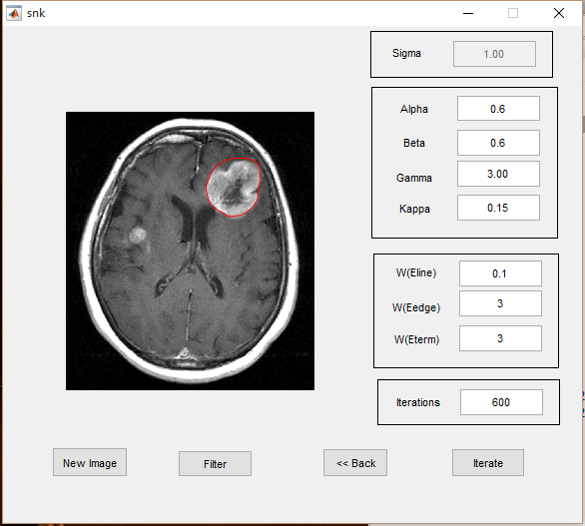

**Figure 2. Snake Algorithm of Brain Image. Alpha = 0.6, Beta = 0.6, Wline = 0.1, Wedge = 3, Wterm = 3**

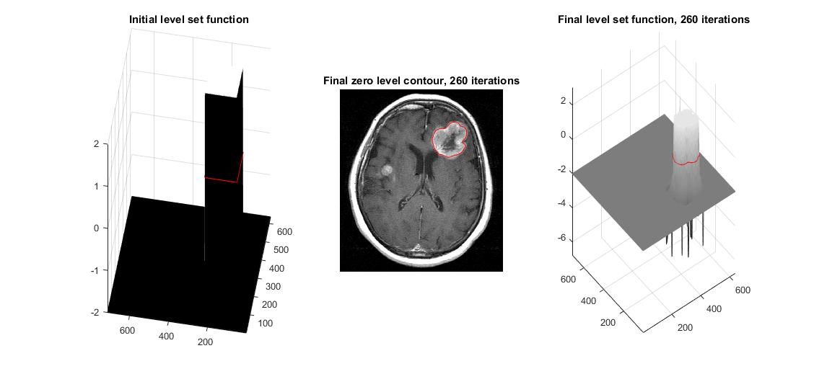

**Figure 3. Level-Set Algorithm of Brain Lambda = 5, Alpha = 2**

* 1. **Discussion**

**2.4.1 Snake Algorithm**

There are several perimeters in Snake Algorithm.

Alpha and beta. Alpha specifies the elasticity of the snake and Beta specifies the rigidity in the contour. For example, snake algorithm of blood cells in Figure ? and Figure ?, when alpha and beta increase from 0.3 to 0.4, the final contour contract a little bit because the contour become more rigid.

Wline, Wedge, Wterm. Wline is the weighting factor for intensity based potential term. In the first Spine Figure, we can see that the sign of Wline influent the contour direction. Wedge is the weighting factor for edges. For example, in Blood Cell Case, we has to decrease the Wedge to avoid the influence of other white cells. Wterm is the weighting factor or termination potential term. Here I always increase the weight of Wterm if I need to avoid other noise line and want the contour is determined by energy.

The Snake Algorithm depends on the selection of the initialization point. If the number of selected points is too small or too far away from the target, then the result will be not good enough to detect the contour.

**2.4.2 Level-Set Algorithm**

We can see level-set algorithm mainly depends on three factor: LSF (Level-Set Function), lambda and alpha. The LSF is like the selection point in Snake Algorithm. We can use LSF to adjust the target we want. In the following three images, we can that alpha determine the size of the contour, it like the elasticity of the contour, and Lambda influent the sensitive to the edge or line in the image.



**Figure 3. Level-Set Algorithm of Coronary. Lambda = 5, Alpha = 2**

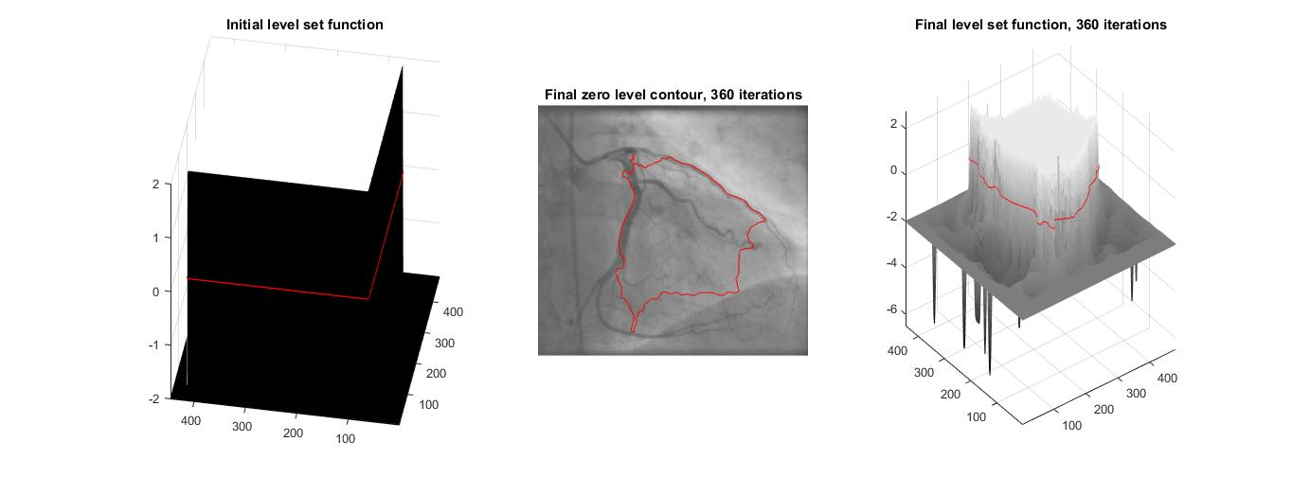

**Figure 3. Level-Set Algorithm of Coronary. Lambda =2, Alpha = 2**

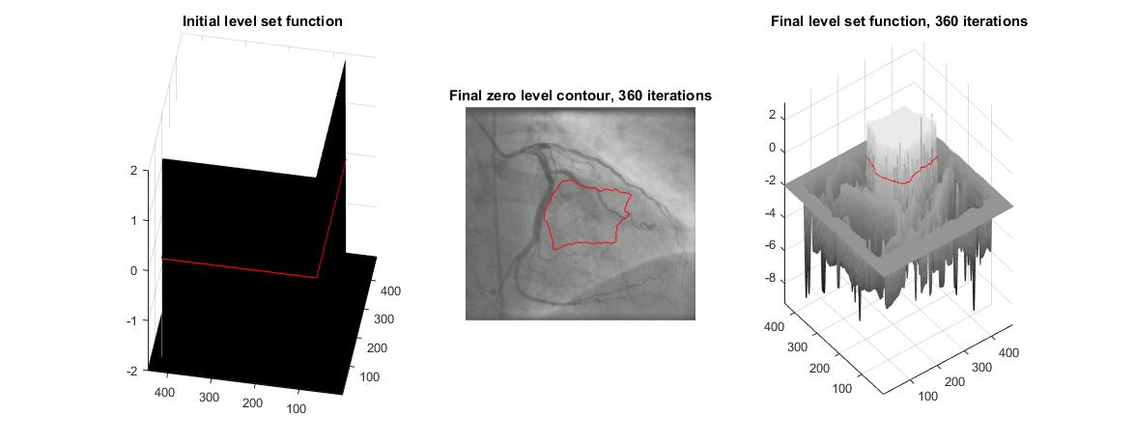

**Figure 3. Level-Set Algorithm of Coronary. Lambda =2, Alpha = 5**

**2.4.3 Compare two methods**

Heuristic information. Both Level-set and Snake Algorithm need an external heuristic information. Compared to LSF, the selection of initialization points in Snake Algorithm is easier to adjust. So we can use Snake Algorithm to extract the shape in the image which we can first select by ourselves.

Shape. Level-Set method perform better in non-round contour image, and Snake Algorithm perform better in round-shape contour image.

Spend time. The level-set spend much more time then Snake Algorithm.

**Reference**

[1] Snakes: Active Contour Models, KASS

[2] Li, Chunming, et al. "Distance regularized level set evolution and its application to image segmentation." *Image Processing, IEEE Transactions on* 19.12 (2010): 3243-3254.

[3] <http://www.mathworks.com/matlabcentral/fileexchange/12711-level-set-for-image-segmentation>

[4] <http://www.mathworks.com/matlabcentral/fileexchange/28109-snakes--active-contour-models>

**Problem 1. Optical Character Recognition (OCR)**

**1.1 Summary**

Optical Character Recognition (OCR) is used to analysis the shape in the images like typed, handwritten or printed text. In this problem, we use OCR to detect and analysis the character in four images by developing a decision tree.

1.2 Algorithm and Implementation

1.2.1

Test1

Convert to gray image

Convert to binary image

Segment the image to 12 sub-images

Thinning the image

Test2

Convert to gray image

Convert to binary image

Close Operator to the image to smooth the image

Segment the image to 12 sub-images.

Thining the image

Test3

Convert to gray image

Histogram equalization

Convert to binary image

Close Operator to the image to smooth the image

Segment the image 13 sub-images

Thinning the image

Test4

Convert to gray image

Convert to binary image

Dilate Operator to the image to hole-filling